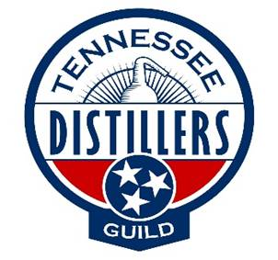
APPLICATION FOR MEMBERSHIP

Company Name:

Contact Name: Phone:

Email Address:

Billing Address:

Company Description: (Please list your products, brands, services, etc.)

Type of Membership requested:

DSP # (Full Members Only):
Type of Membership is based on criteria listed below:

Distillers: This category is reserved for the independent distilleries already manufacturing spirits under a DSP in Tennessee.
Sliding scale based on number of cases sold annually

Appliers: This category is reserved for those who have applied for their DSP's, but are awaiting approval and setting up their businesses.
$500 annually

Associate Members:
Level One- This category will receive access to member Distillers’ and Appliers’ contact information, inclusion of company logo on the Guild website and the opportunity to attend a networking event with member Distillers and Appliers
$1500 annually

Level Two- This category will receive access to member Distillers’ and Appliers’ contact information and inclusion of company logo on the Guild website
$750 annually

